**TALEND ASSIGNMENT - 1**

1. **CSVtoXML**

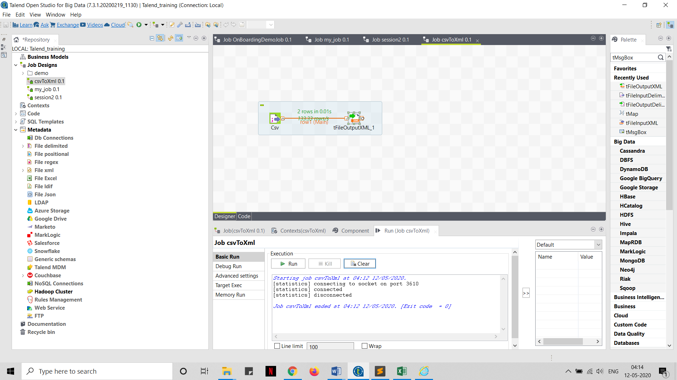

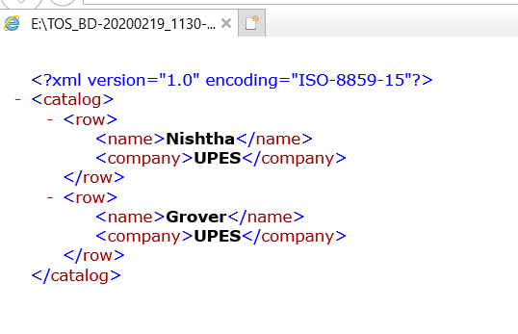

1. **Remove Extra Spaces**

Removed the extra spaces in merged Address1 and Address2 using Trim() function.

